LAB ASSIGNMENT-4.2

AI Assisted coding

Name: K.Pardhasaradhi

Htno: 2403A52001

TASK-1:

Zero-shot: Prompt AI with only the instruction .Write a Python function to generate the Fibonacci sequence up to n terms.

Prompt: Generate a python code of Fibonacci sequence up to n terms.

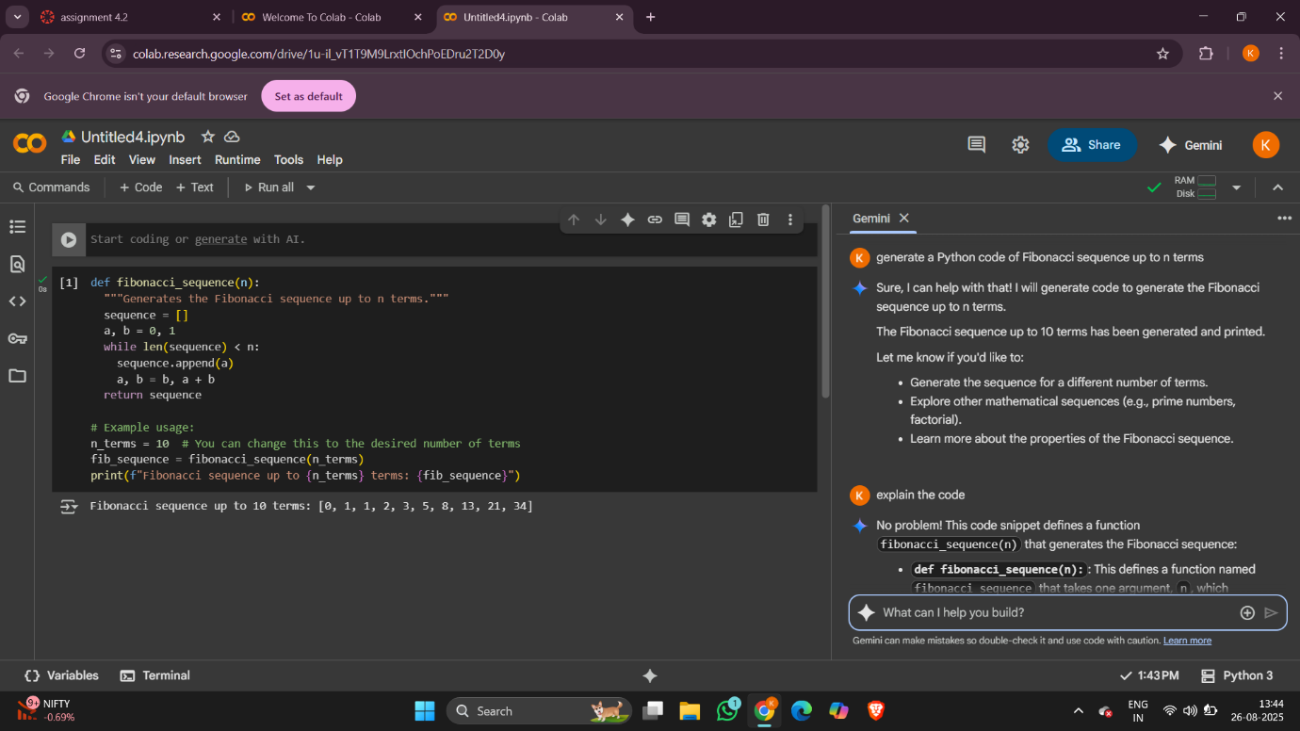

CONCLUSION: The zero-shot prompt asked the AI to generate a Python function for the Fibonacci sequence using only the instruction. The code works correctly and gives the sequence up to *n* terms. This shows that zero-shot prompting is useful for simple and well-known problems. However, for more complex tasks, giving examples (few-shot prompting) would guide the AI better and produce more accurate results.

TASK-2:

One-shot: Provide one example: Input: 100 Output: 37.78 to help AI generate a function that converts Fahrenheit to Celsius.

Prompt: For example input: 212 and output: 100 now generate a python code that coverts Fahrenheit to Celsius

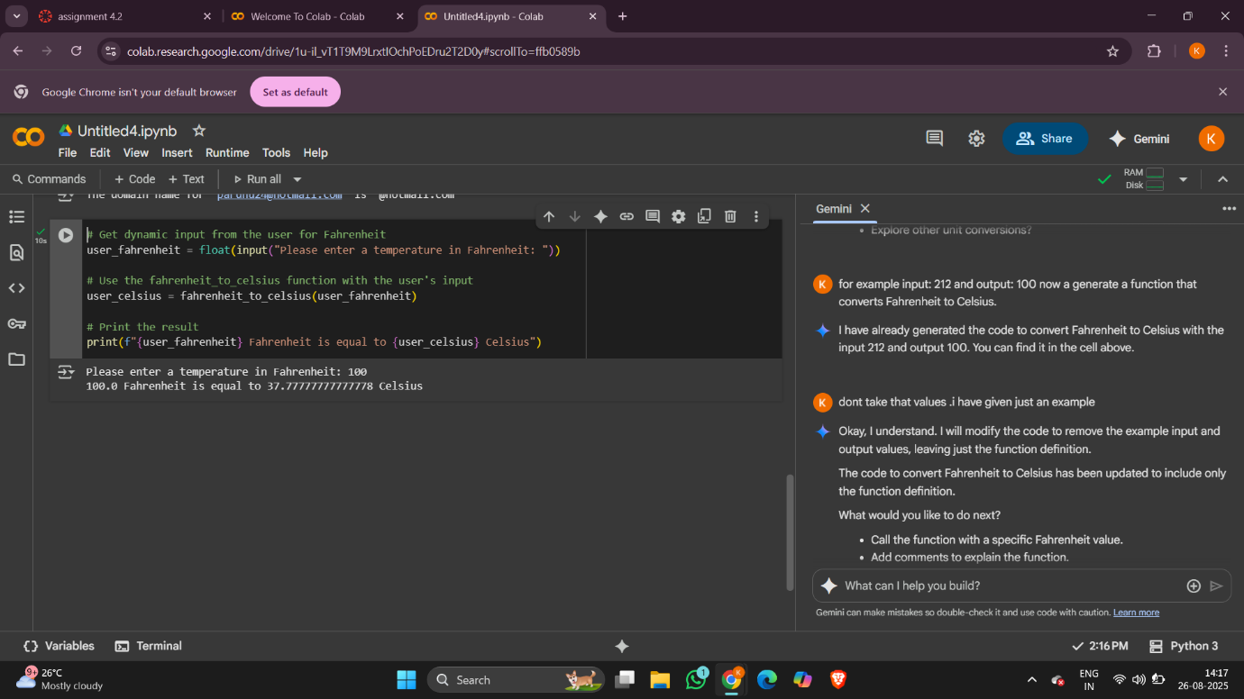

CONCLUSION: Using a one-shot prompt, the AI was given a single example (Input: 100 → Output: 37.78). This guided the AI to understand both the formula and the expected output format. Compared to zero-shot prompting, one-shot makes the result more accurate and consistent because the AI learns from at least one demonstration. For simple problems, zero-shot may work, but one-shot improves reliability by showing the AI exactly what is expected.

TASK-3:

Few-shot: Give 2–3 examples to create a function that extracts the domain name from an email address.

Prompt: Write a Python function that takes an email address as input and extracts the domain name. for example input:pardhu123@gmail.com and output :@gmail.com , input : ram234@hotmail.com and output : @hotmail.com , input: rajesh54@yahoo.in and output : @yahoo.in

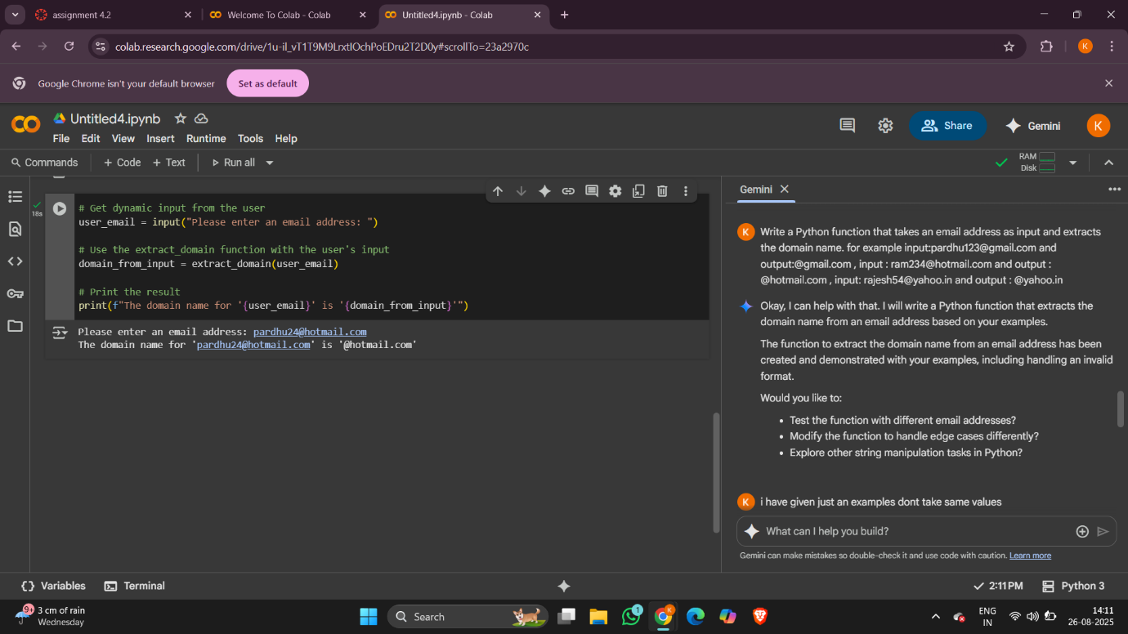

CONCLUSION: The program successfully extracts the domain name from an email address by locating the @ symbol and returning the remaining part of the string. It works correctly for different inputs like Gmail, Hotmail, and Yahoo. This shows how string manipulation in Python can be used to solve real-world problems such as processing and validating email addresses.

TASK-4:

Compare zero-shot vs few-shot prompting for generating a function that checks whether a word is a palindrome, ignoring punctuation and case.

Prompt:

ZERO-SHOT: Write a Python function that checks whether a given word is a palindrome. The function should ignore punctuation, spaces, and letter case.

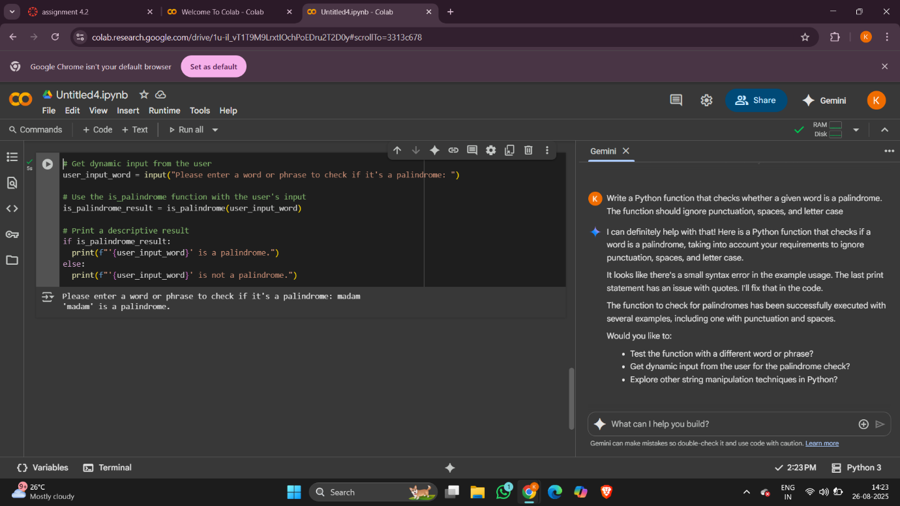

FEW-SHOT:

Write a Python function that checks whether a given word is a palindrome. The function should ignore punctuation, spaces, and letter case for example input: madam and output: madam is palindrome ,input : hello and output: hello is not palindrome , input: racecar and output : racecar is palindrome.

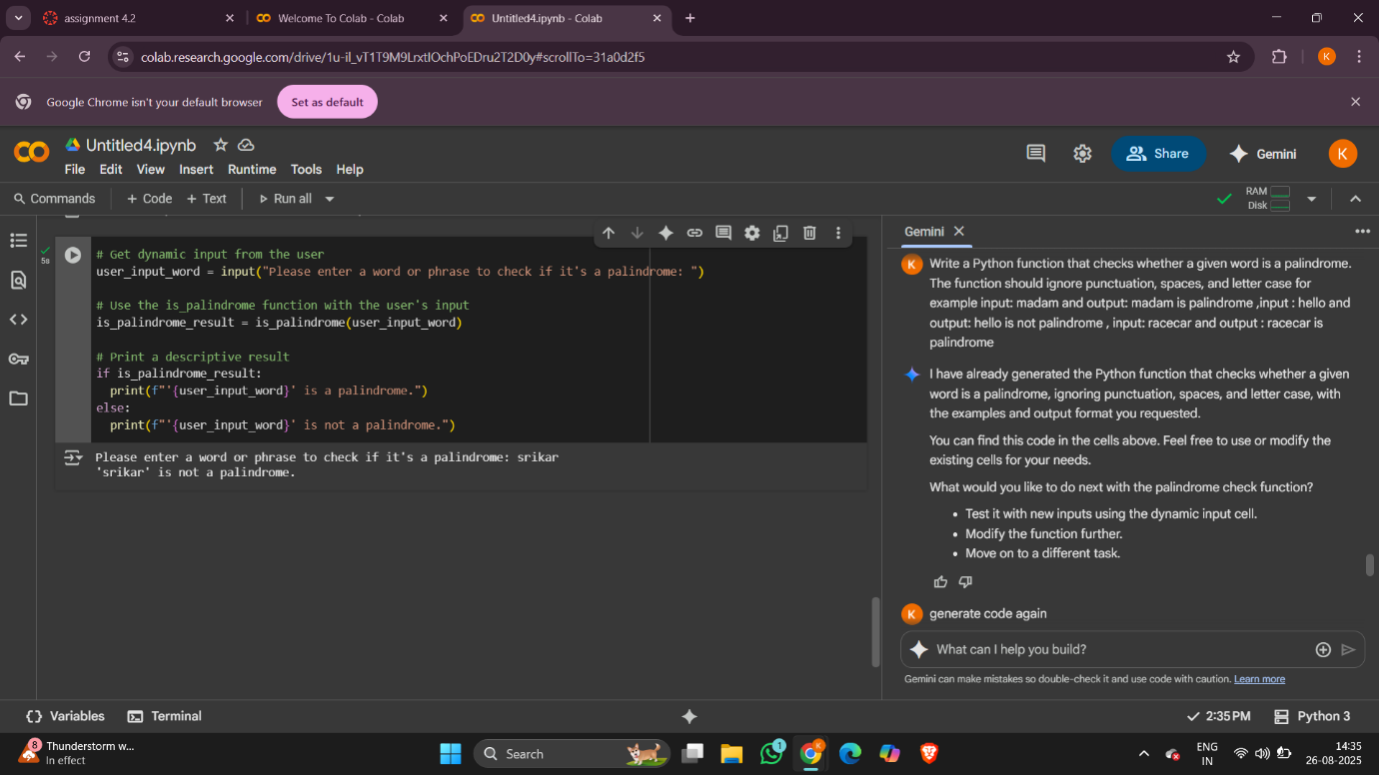

CONCLUSION:

**Zero-shot prompting** is faster and works if the task is simple and unambiguous, but risks misinterpretation.**Few-shot prompting** is more reliable because examples clarify expectations and edge cases, leading to better, more accurate code. For a task like palindrome checking (where rules like ignoring punctuation and case matter), **few-shot prompting is superior**.

TASK-5:

Use few-shot prompting with 3 sample inputs to generate a function that determines the maximum of three numbers without using the built-in max() function.

Prompt:

Write a Python function that determines the maximum of three numbers without using the built-in max() function. for example : Input: (3,7, 5) and Output: 7 , Input: (10, 2, 8) and Output: 10,Input: (-4, -9, -1) and Output: -1. provide me input in dynamic way.

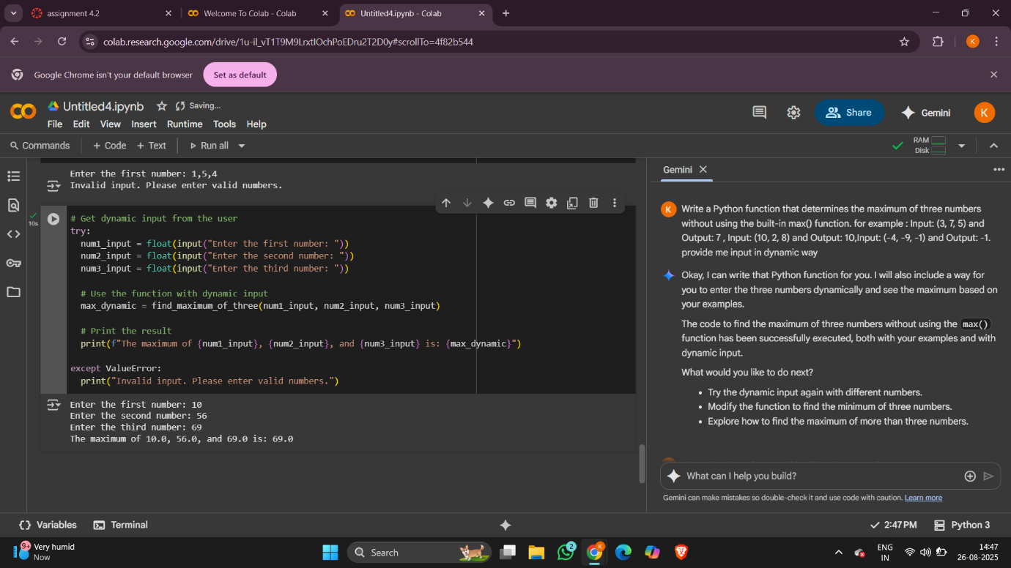

CONCLUSION:

The program correctly determines the largest of three numbers without using the built-in max() function. By comparing the numbers step by step with conditional statements, it can handle positive, negative, and mixed inputs. This shows how logical thinking and control structures in Python can replace built-in functions to solve problems efficiently.